Angular 5 Best Practices

Design the components first before starting to code.

* Apply the single responsibility principle (SRP) to all components, services, and other symbols. This helps make the app cleaner, easier to read and maintain, and more testable.
* Draw outlines on the screen mockups to clearly demarcate which screen area will be owned by which component.

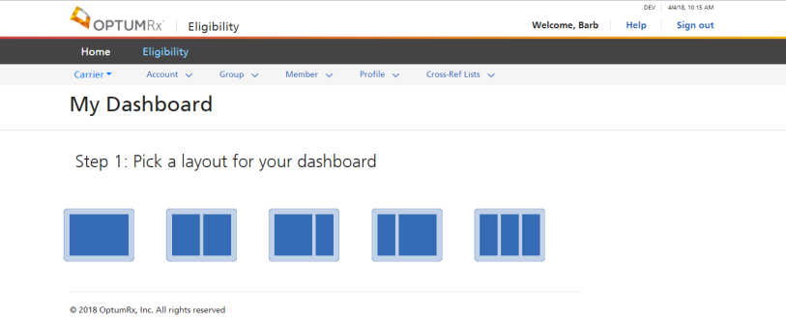

Header 🡪

Menu🡪

SubMenu🡪

Content🡪

(router-outlet)

Footer 🡪

* Make the components small enough so that they can be reused in multiple places.
* Document the @Inputs that will be provided and the @Outputs that each component emits.
* Design each component with reusability in mind and store them in a SharedModule.
* Follow the design used by generating a module or component using Angular CLI. Each component should be in its own folder and contain 4 files: xxx.component.css, xxx.component.html, xxx.component.ts, and xxx.component.spec.ts (where xxx is the component name).
* Do not use inline templates. All templates should be in their own html file.
* Use lazy loading on all the non-first-page routes.
* Use services to strive for complete segregation between the View implementation and Business logic. The view should only render the data and the services should be responsible for making any calls to the database and for any functional logic.

Compiling/Transpiling

* Usage of AoT (ahead of time) compilation to improve runtime performance. It reduces your bundle by about 30kb (gzipped) which is a LOT of improvement. Angular 4.0+ brings about 30% improvement in app bundles due to how it generates the AoT code.

For AOT compilation, append the --aot flags to the *build-only* or the *build-and-serve- locally* CLI commands:



The --prod meta-flag compiles with AOT by default

See https://angular.io/guide/aot-compiler

Follow the guidelines suggested in the Angular Style Guide: https://angular.io/guide/styleguide